**Phase 5**

1.**Apex Classes**

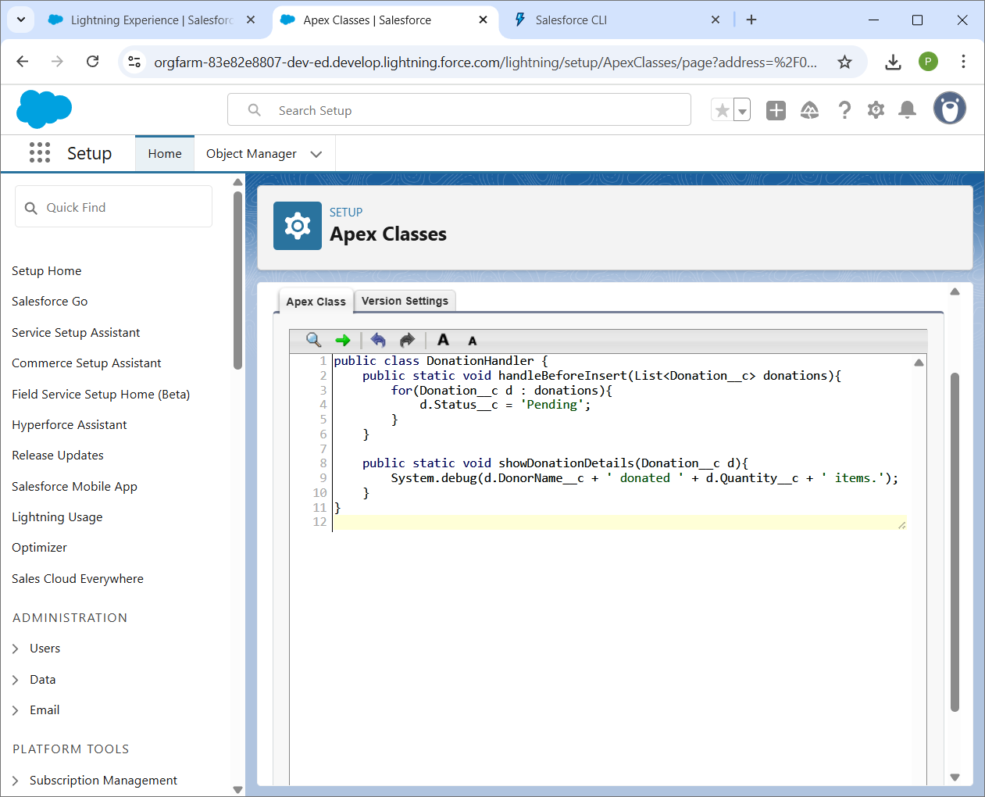

**2.Apex Triggers**

* **Trigger: Code executed before/after DML (insert, update, delete).**
* **Before Trigger: Used to validate/modify records before saving.**
* **After Trigger: Used for operations after record is saved (like sending notifications).**

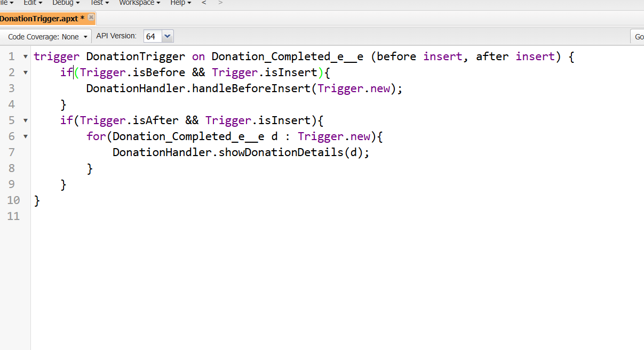

**3. Trigger Design Pattern**

* **Why: Avoid logic duplication, bulk-safe coding.**
* **Pattern: One trigger per object, logic in handler class.**

**}**

**4. Scheduled Apex**

* **Run Apex at scheduled intervals.**

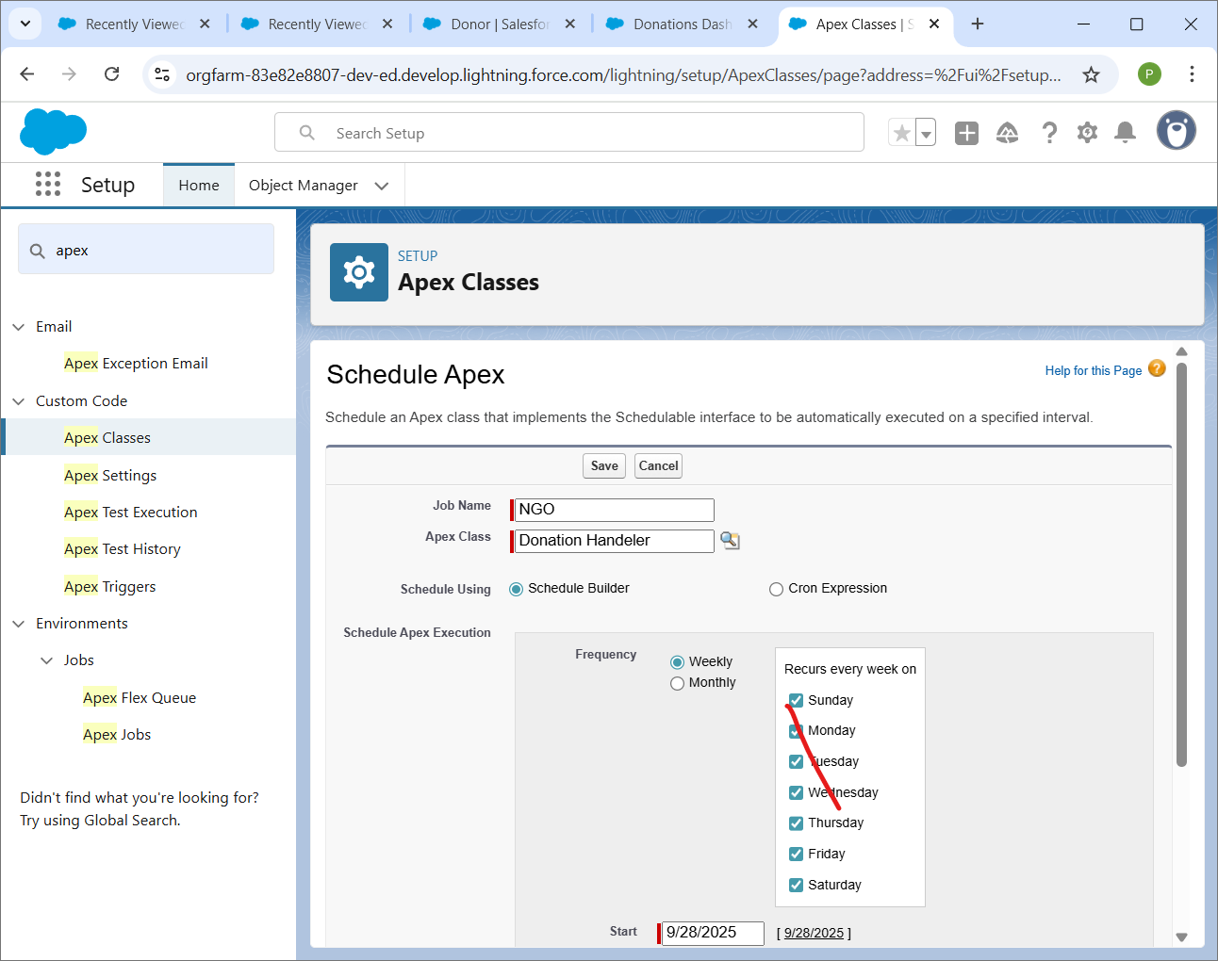

**5. Queueable Apex**

